HVS ROLL 70 86 ASPEK
BRIGHTNESS 72%

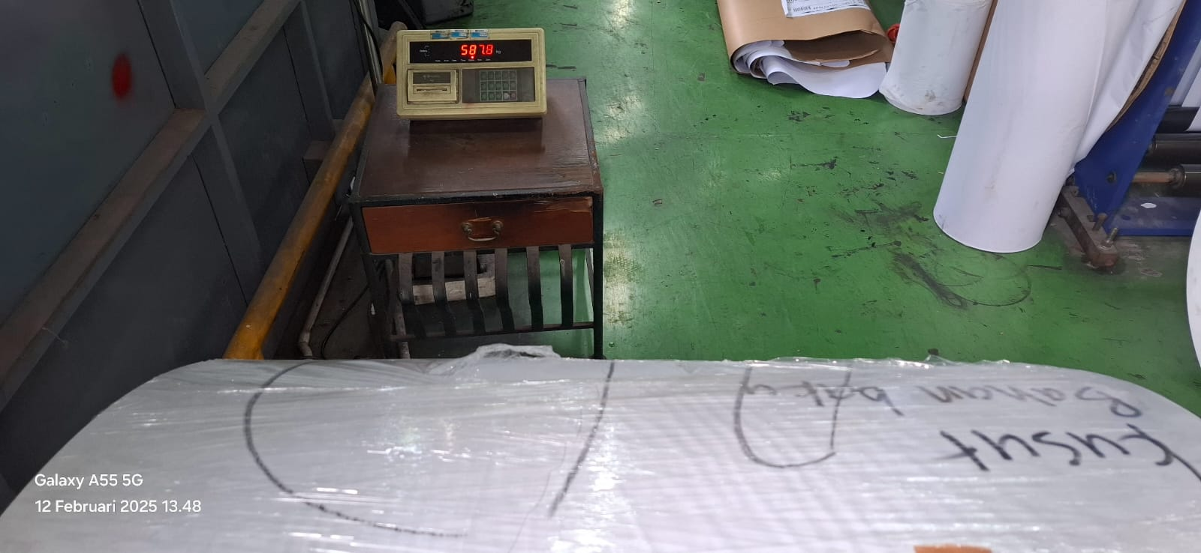

587 kg

